What’s Happening - Event Organizing and Managing Android Application

1. Select “What’s Happening” from the app menu and enter the Phone number and Password as the Login Credentials.

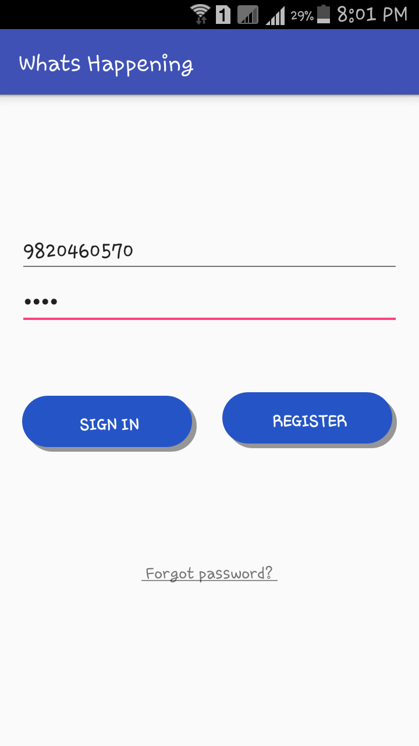

1. If you forgot your password you can click on “Forgot password?” and enter your Phone number to receive a mail informing the user of their password.

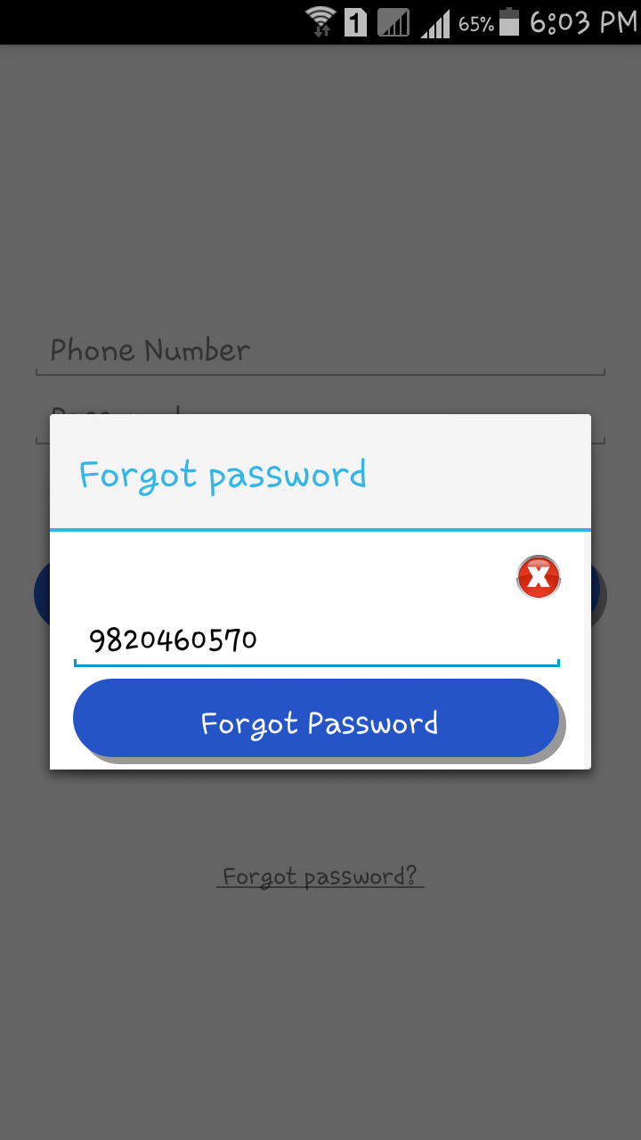

1. Slide the Navigation Bar on the Home Screen to choose various options. Select “My Profile” to view the profile.

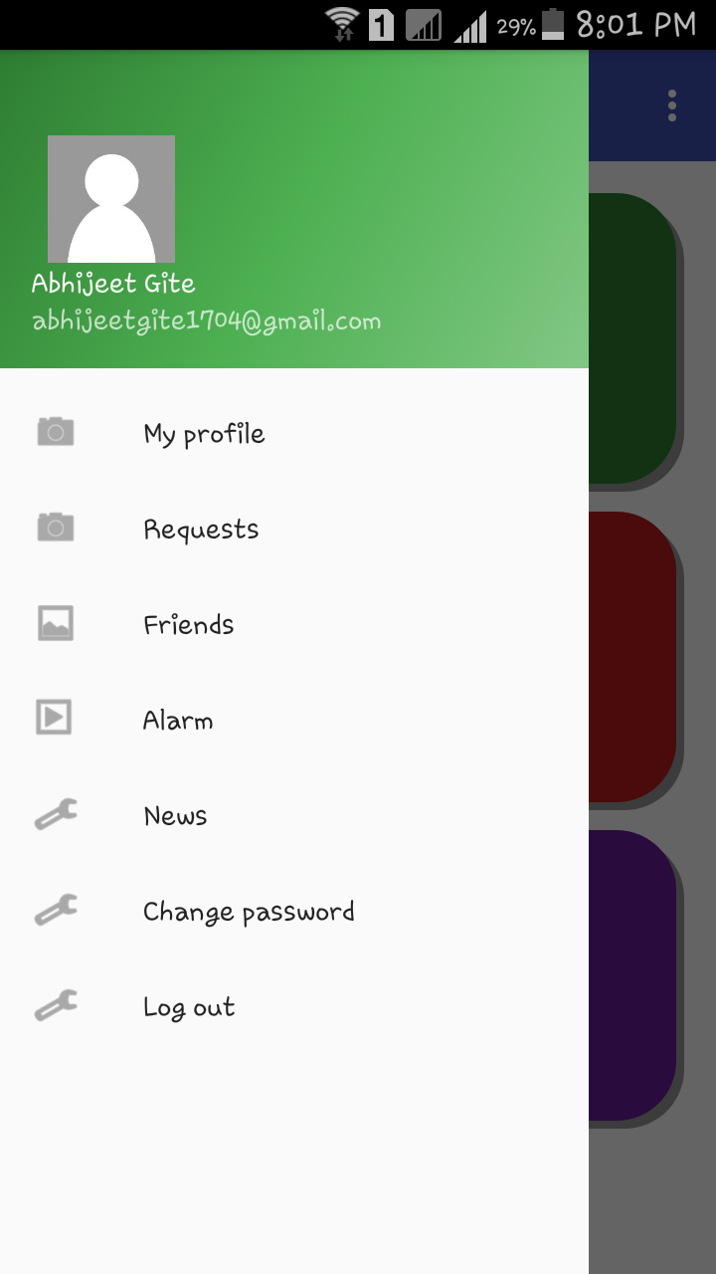

1. Click on Edit button to change the Profile Photo. Choose an image from the gallery and click on Upload image to set that image as your current Profile Photo.

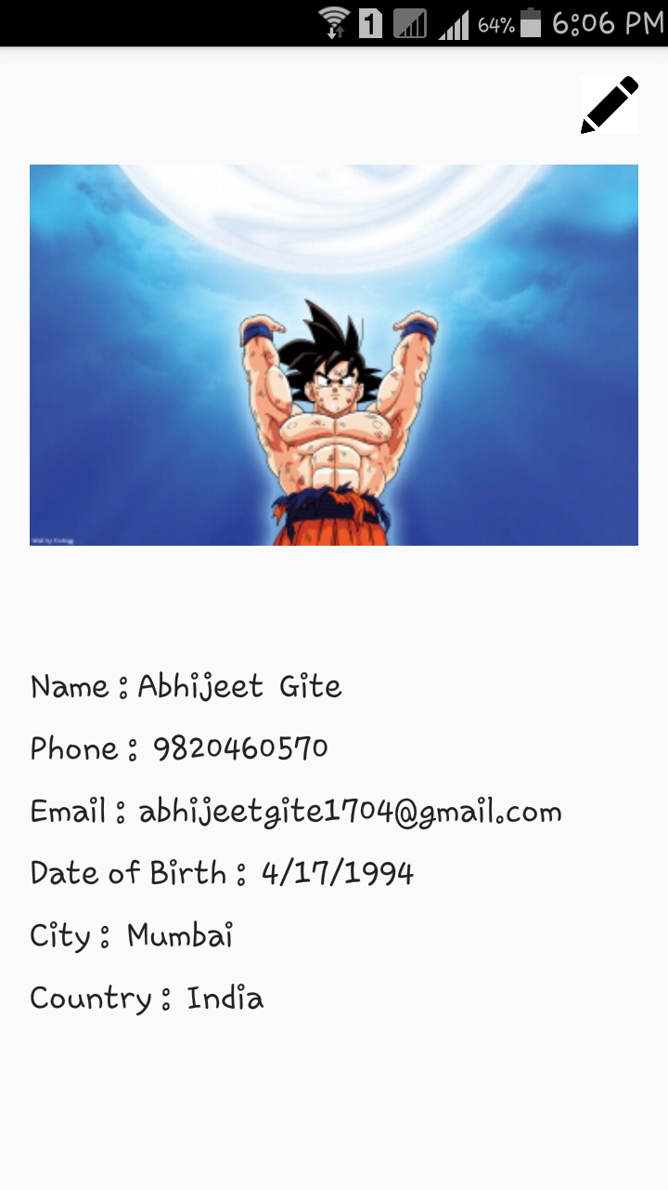

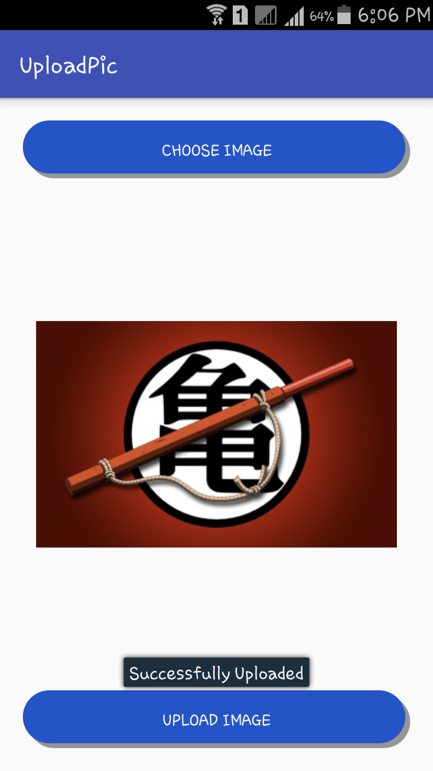

1. Click on “Requests” to view your Friend Requests.
2. Click on “Friends” to view all your friends. The user can also more friends by clicking on the “+” button. A Request will be sent only if the user’s friends are registered users.

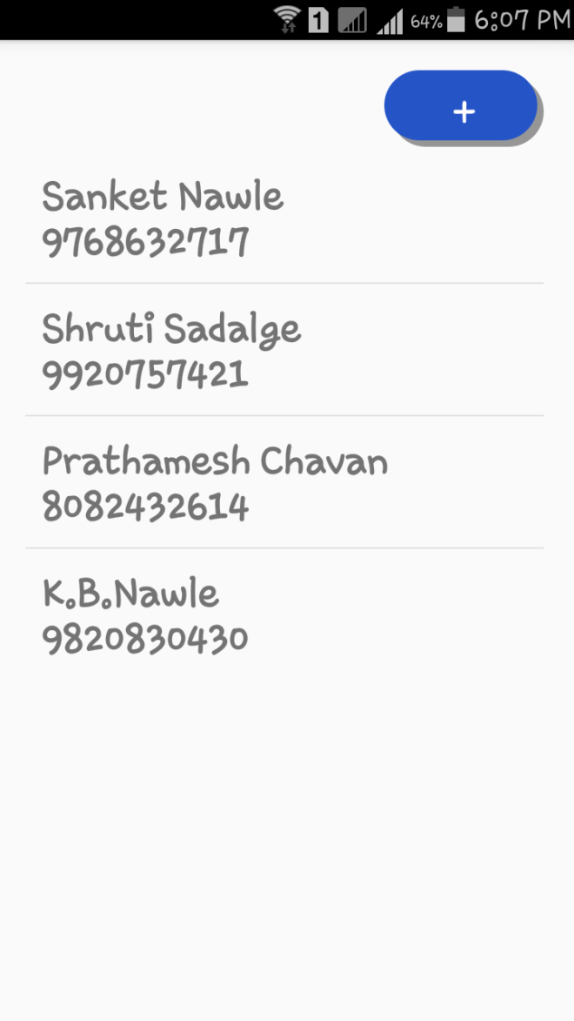

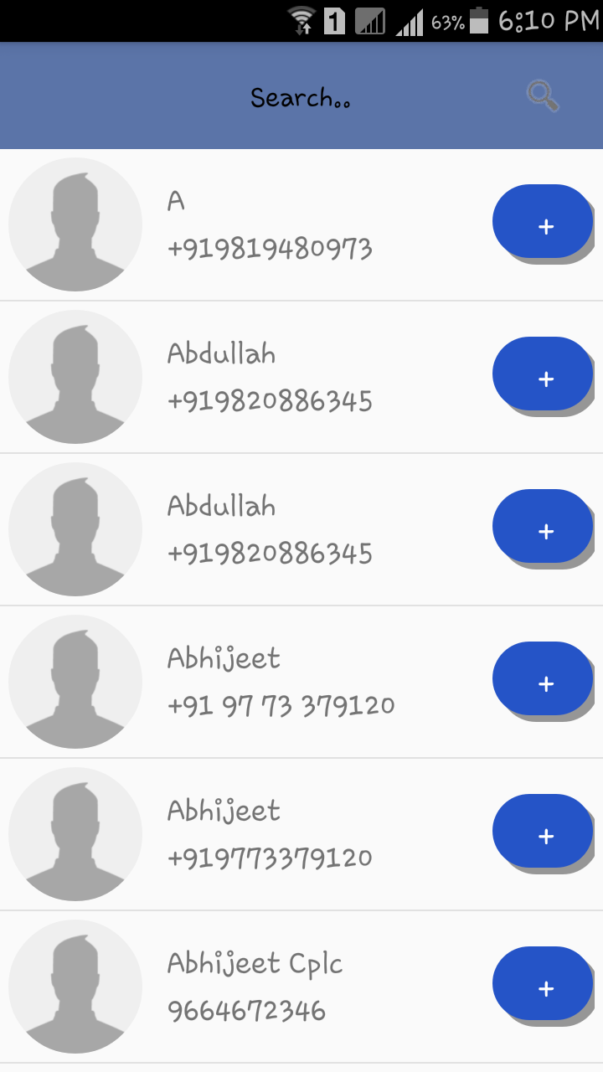

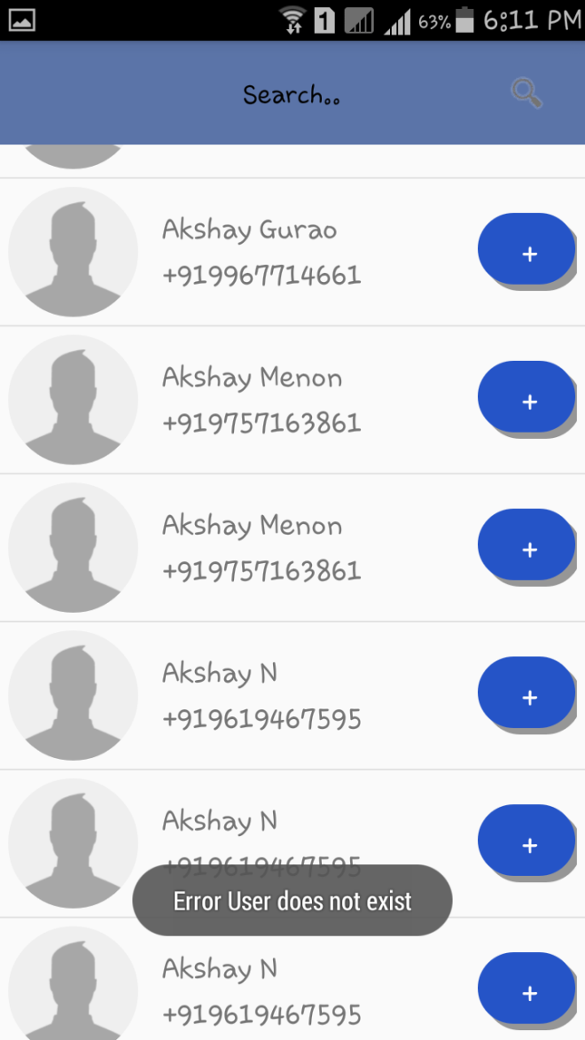

1. Click on “News” to view the News Section

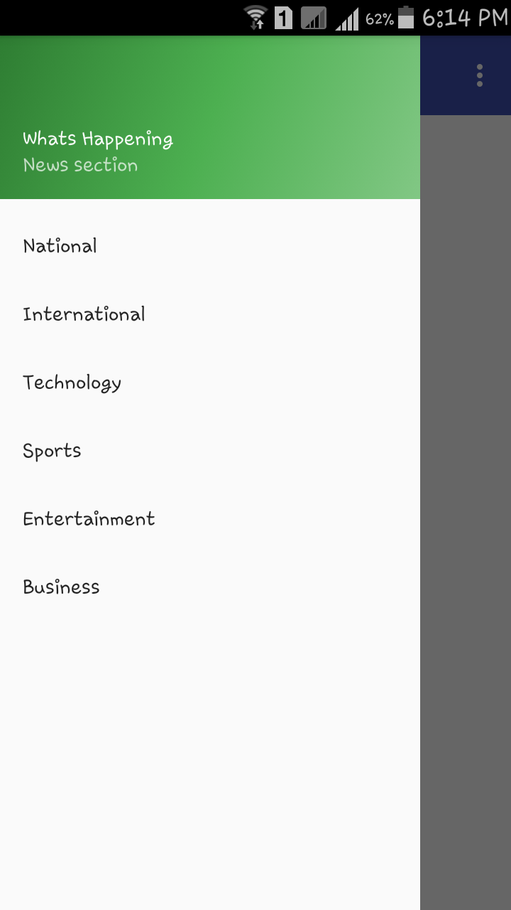

1. The News Section consists of various sub-sections, select any sub-section from the options provided. If the user clicks on any hyperlinks provided in the sub-sections he will be redirected to his default web browser so that the user can read the entire news.

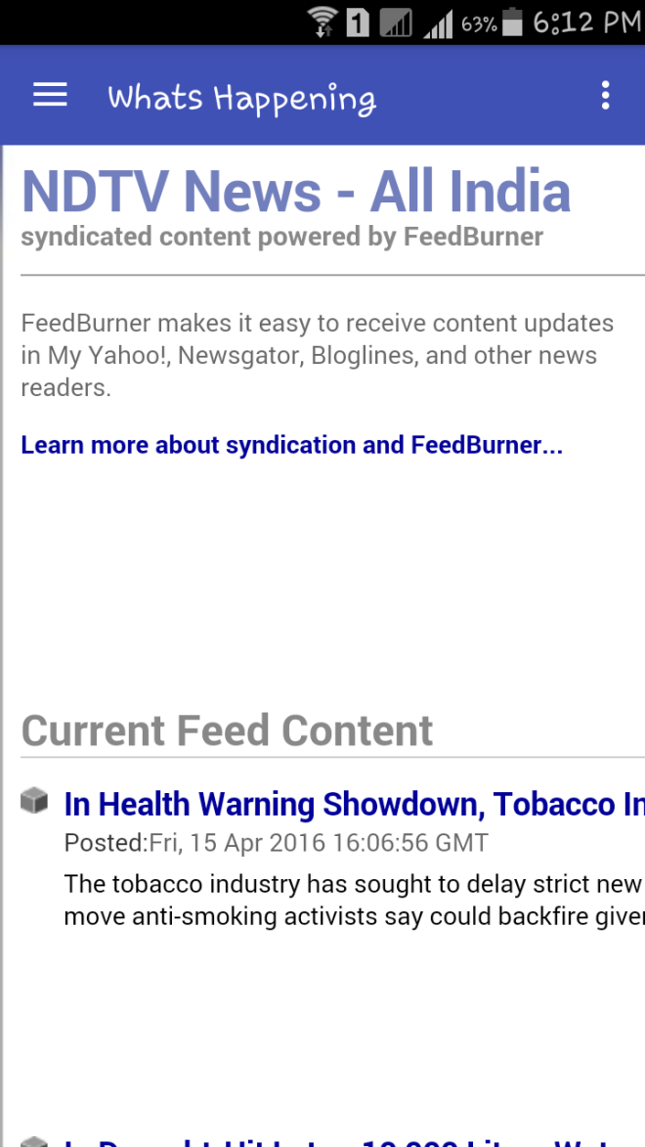

1. Click on “Change Password” incase you want to change your current password. After entering the Phone Number a mail will be sent to the registered email-id.

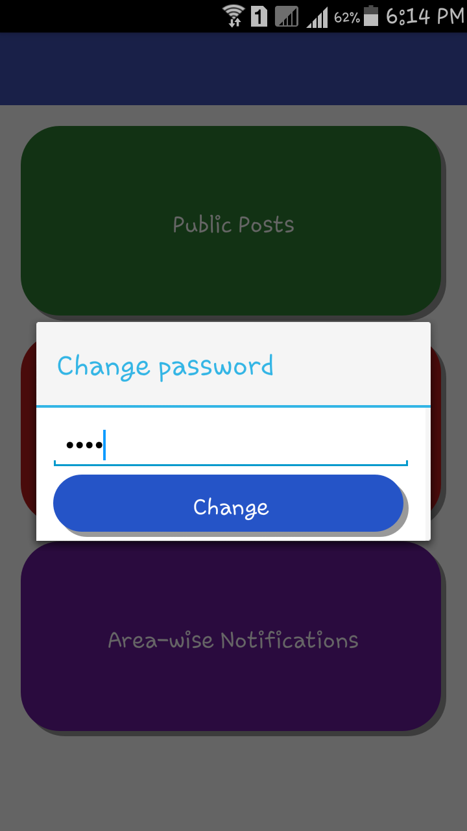

1. Select the “Public Post” feature from the Home Screen. It consists of 2 features Your Events and Received Events.

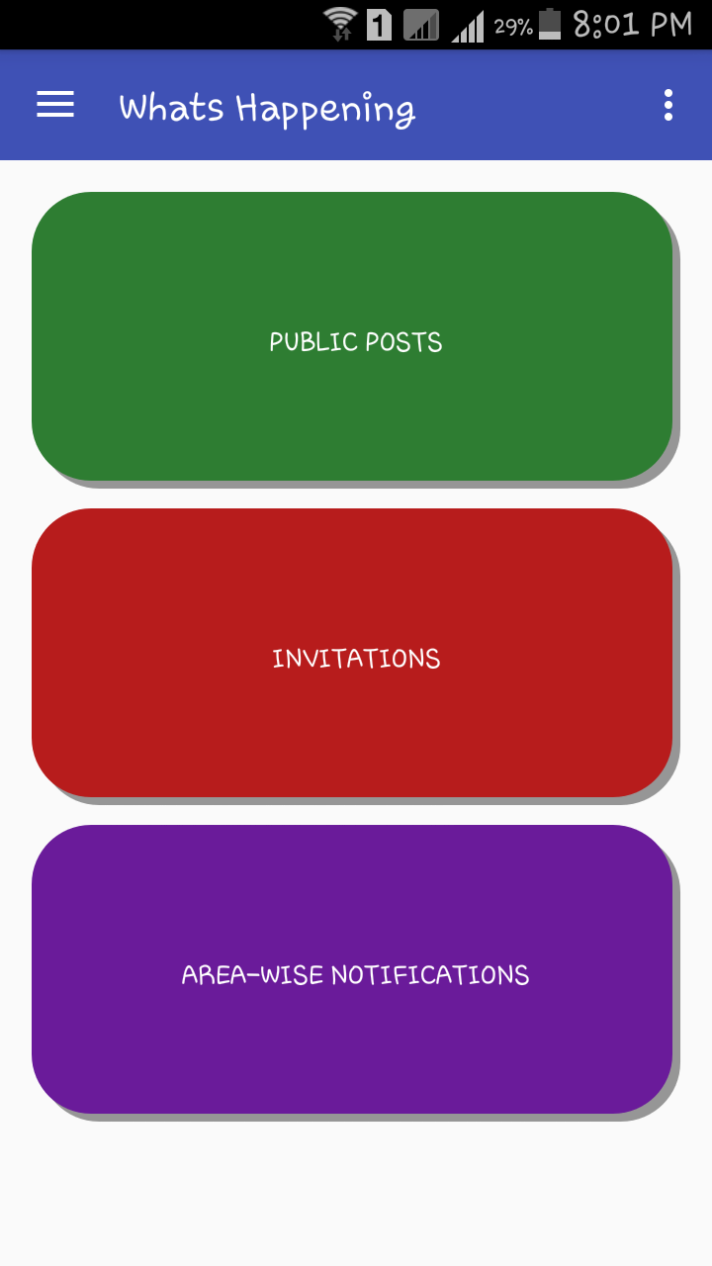

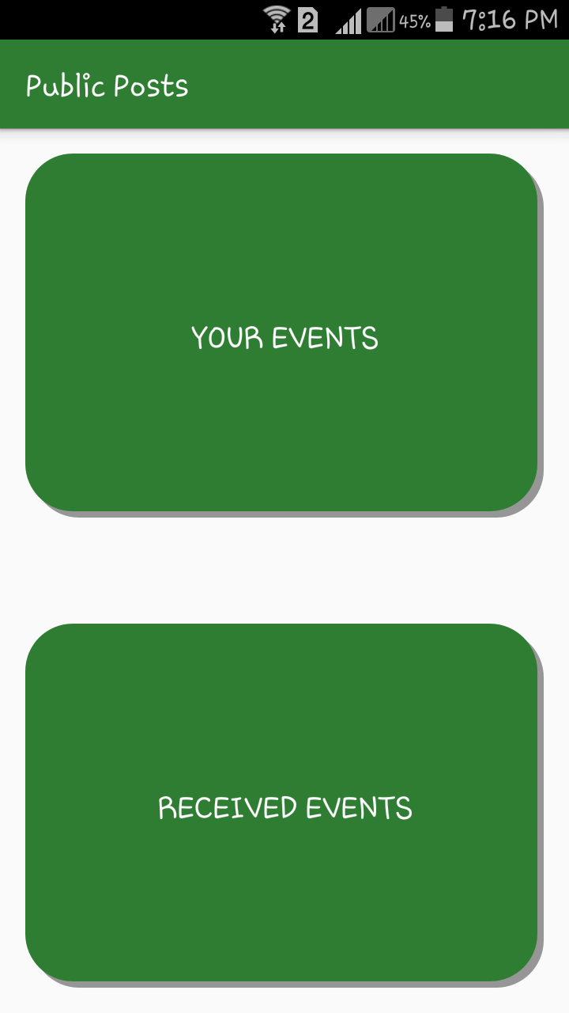

1. Click on Your Events to view the events created. Click on “+” to create a new event. Fill in all the details and send the event to your desired friends.

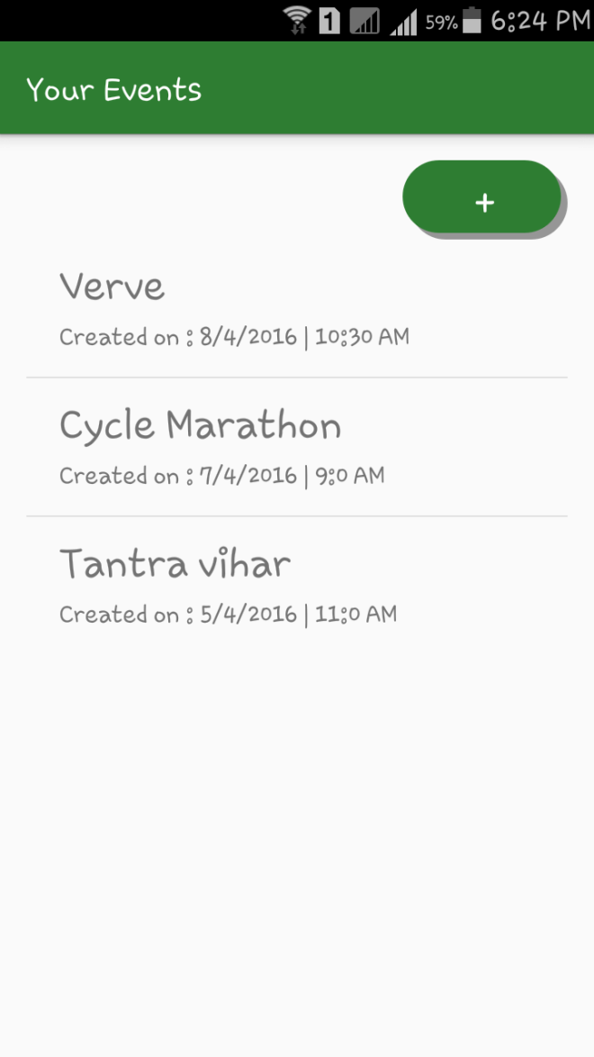

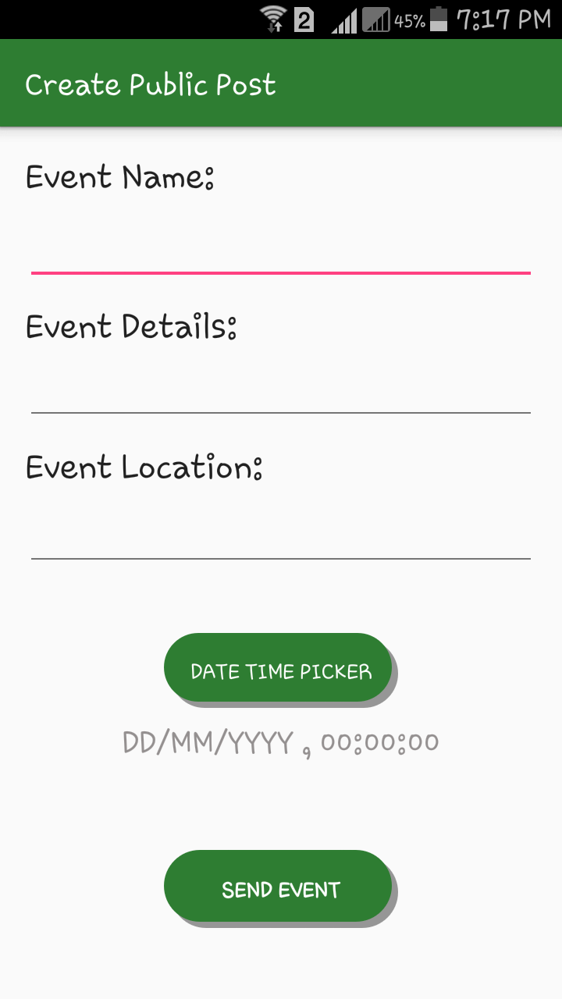

1. Click on Received Events to view all the events received. Click on any event to view that event in detail, you can also add that event to your calendar by clicking on Add Reminder button.

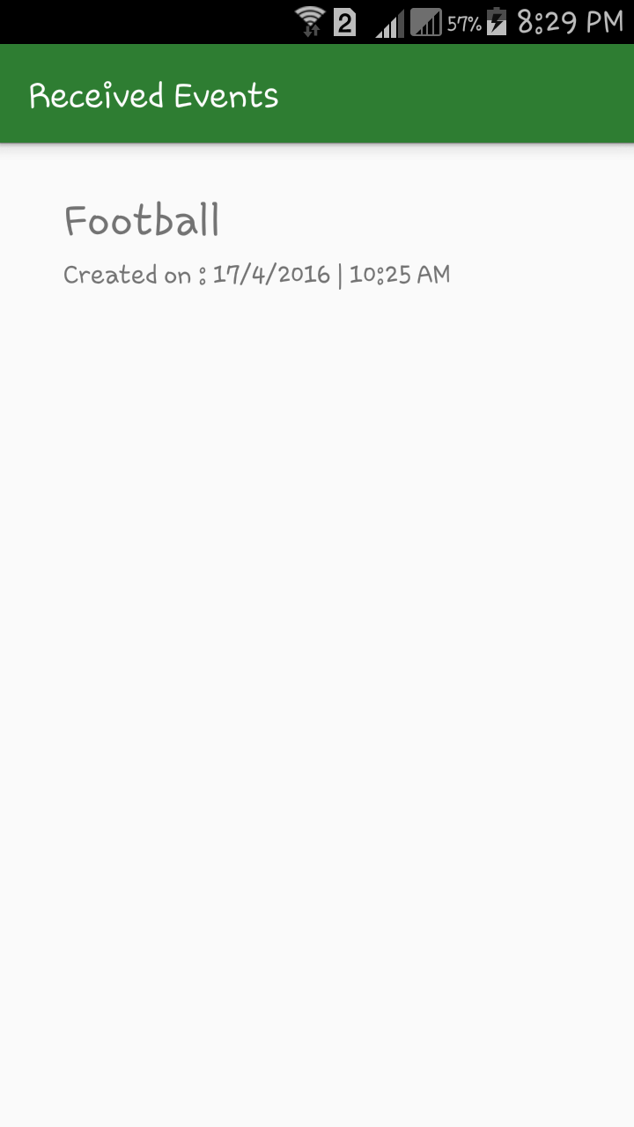

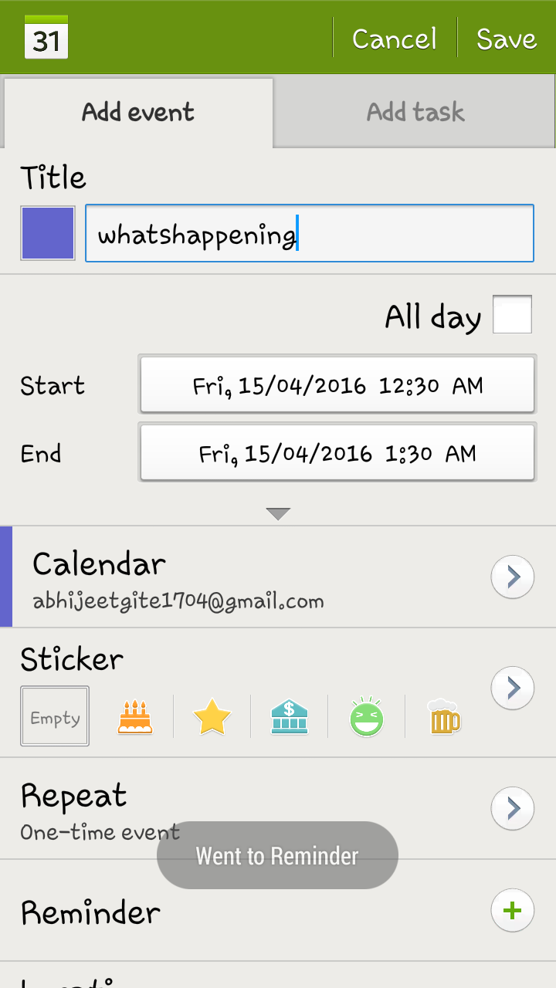

1. Click on the “Invitations” feature from the Home Screen. It consists of 2 features Your Events and Received Events.

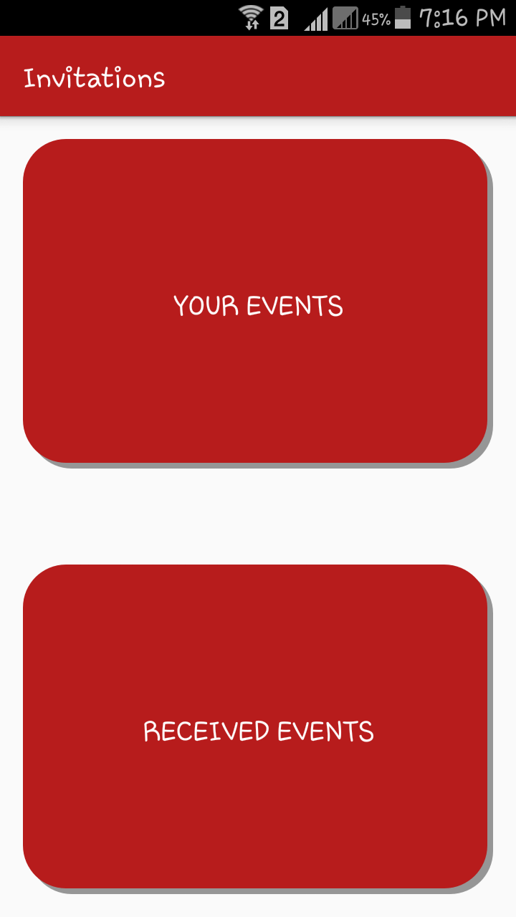

1. Click on Your Events to view the events created. Click on any event to view its details, you can also click on “Event Response” to view the number of people who have responded to your event. Click on “+” to create a new event. Fill in all the details and send the event to your desired friends.

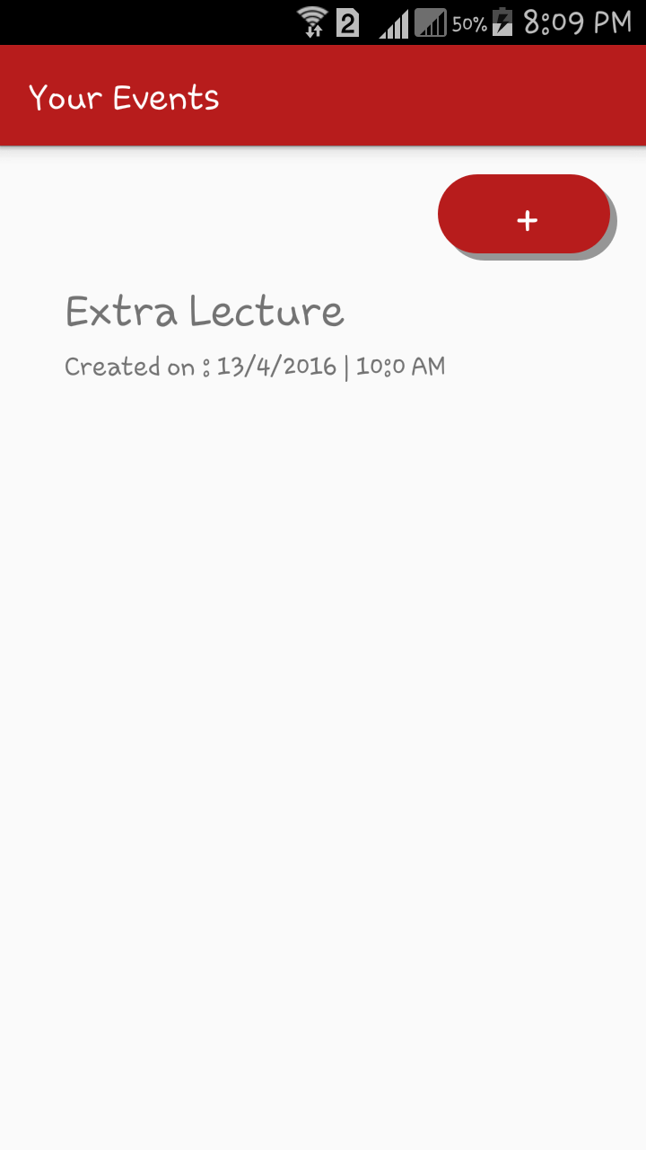

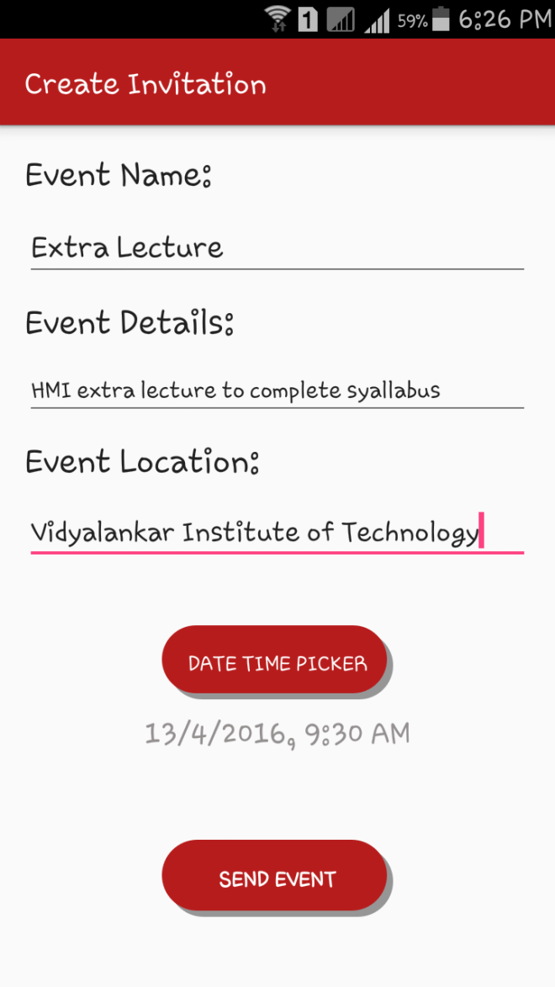

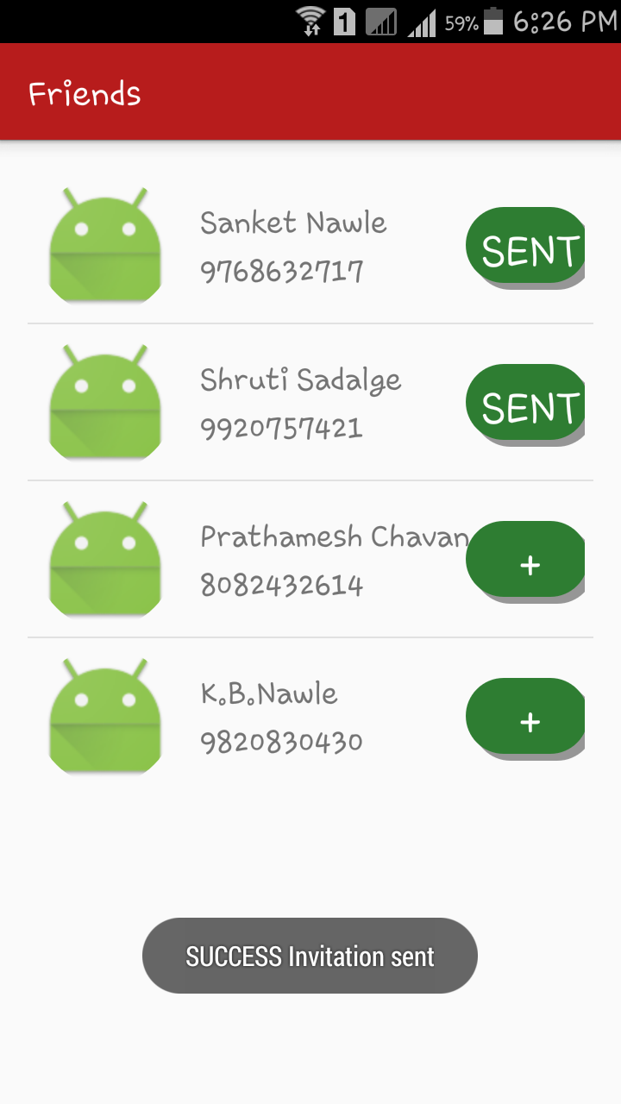

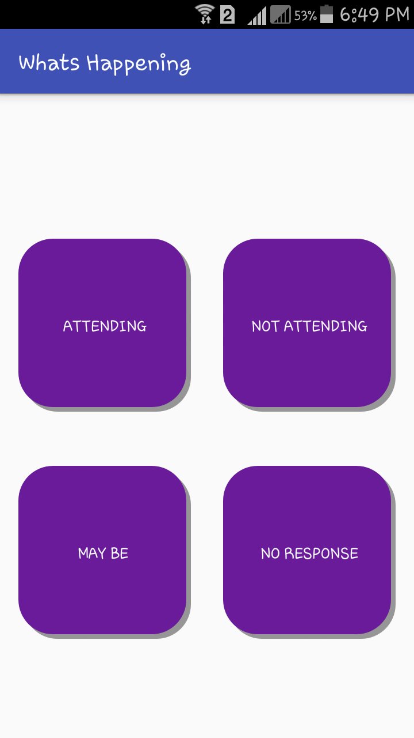

1. Click on Received Events to view all the events received. Click on any event to view that event in detail. Click on “Add Response” to give a response such as attending, not attending or maybe. You can also add that event to your calendar by clicking on Add Reminder button.

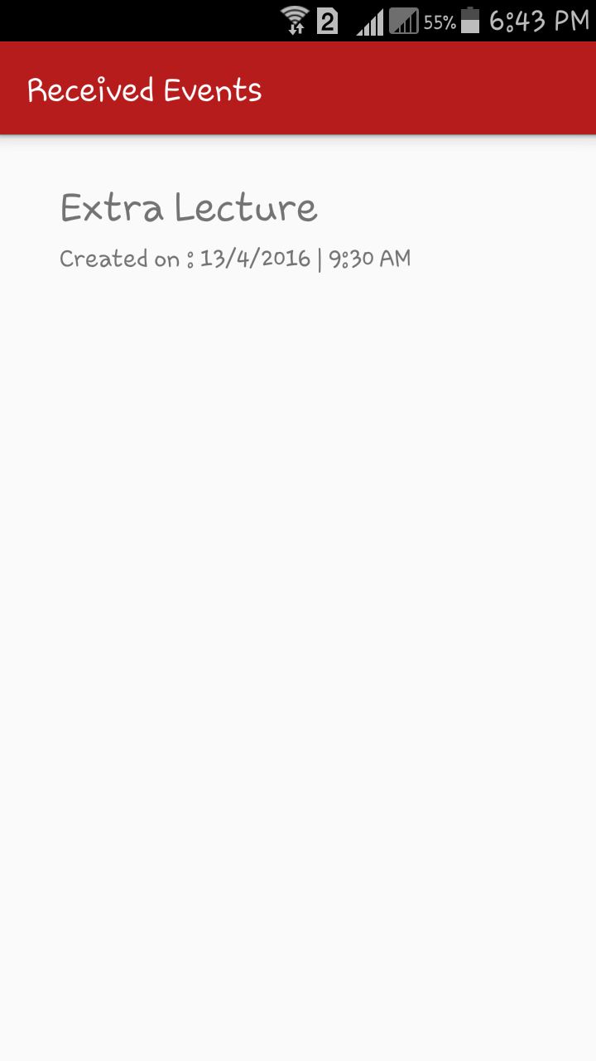

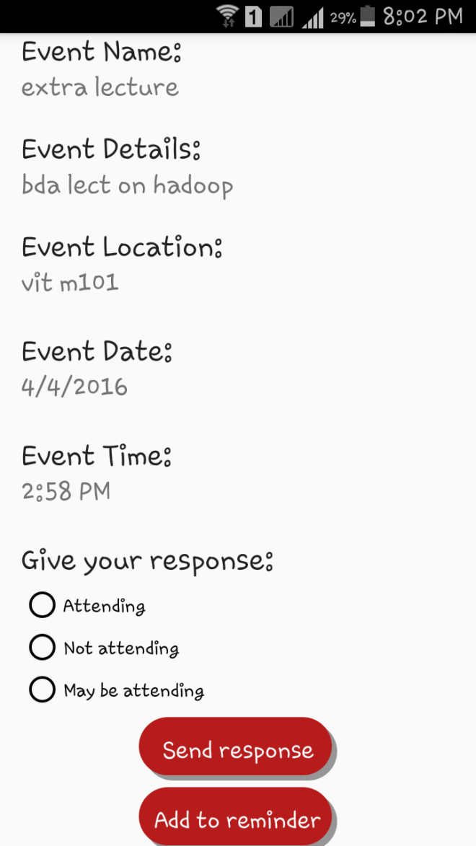

1. Click on “Area Wise Notification” feature from the Home Screen. It consists of 3 features Bluetooth, NFC and Wi-Fi.

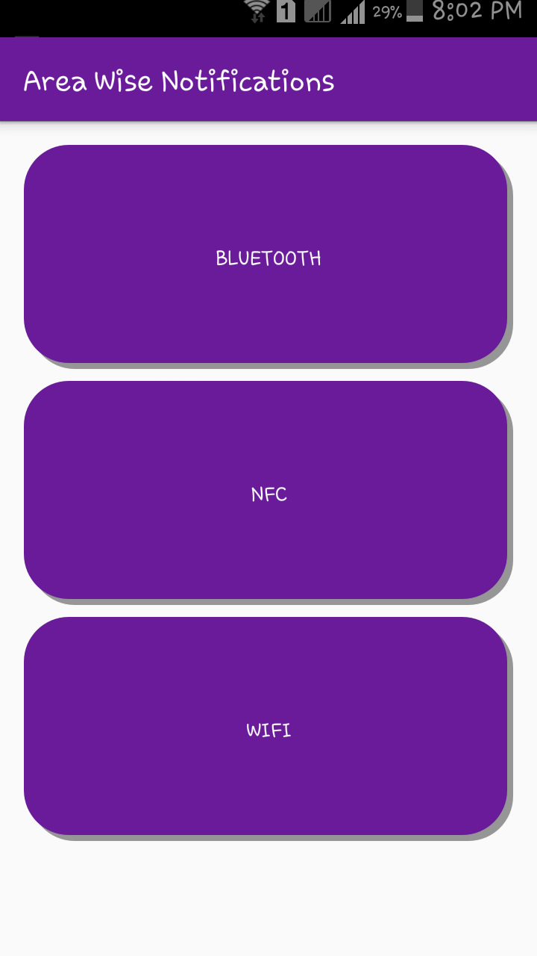

* 1. Click on the Bluetooth feature to Broadcast or Receive a message when using the application for displaying notifications in close range.

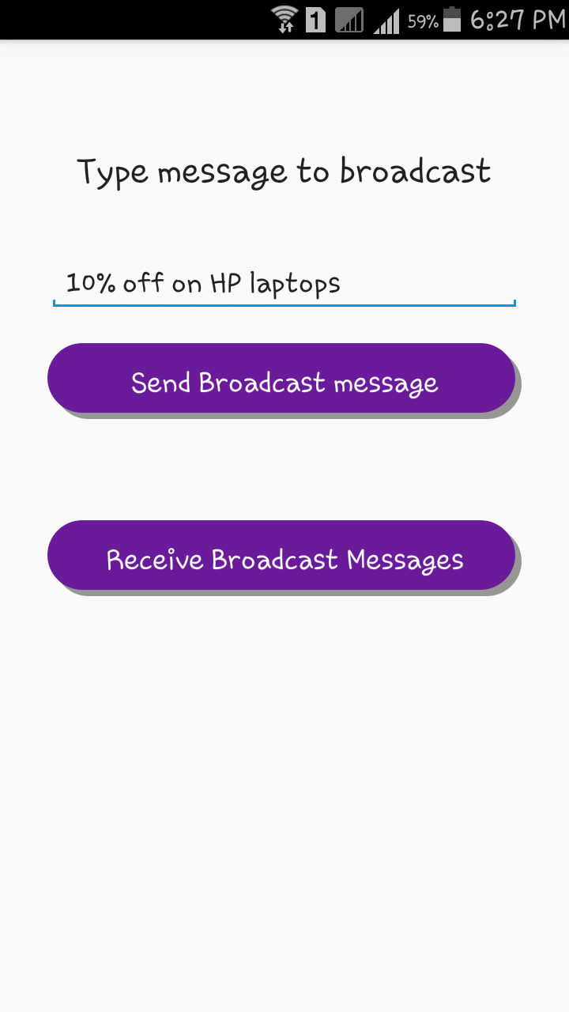

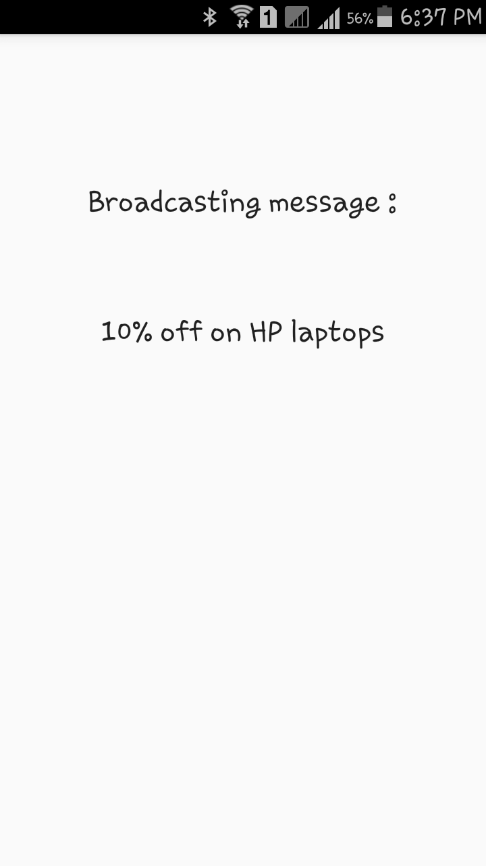

Click on the NFC feature to read a message from a NFC Tag. The application also provides a feature of Writing in to NFC tag but the user first needs to authenticate himself by entering his Email-id.

* 1. Click on the Wifi feature to receive notifications when connected to a Wifi network. Click on any event to view its information in detail.

